**Homework 2**

Problem 1.

Use semantic HTML and create a Web Page like the following.

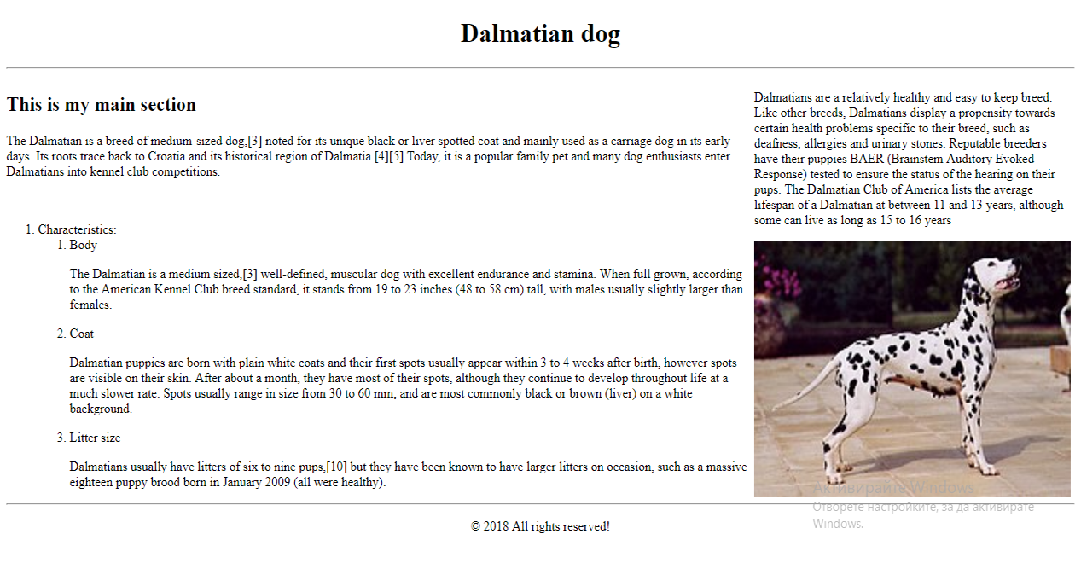

Use the text from Wikipedia: <https://en.wikipedia.org/wiki/Dalmatian_dog>

Problem 2.

Create a Web Page like the following.

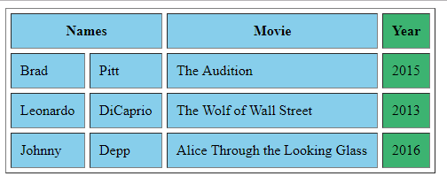

You can find the colors from here: <https://www.w3schools.com/css/css_colors.asp>

Problem 3.

Create a Web Page like the following.

